Panasonic Factory Solutions Announces New Partnership With SMD-Tec

SMD-Tec and Panasonic Factory Solutions announce collaboration to cater to the BeNeLux market
Munich, JulY 2021
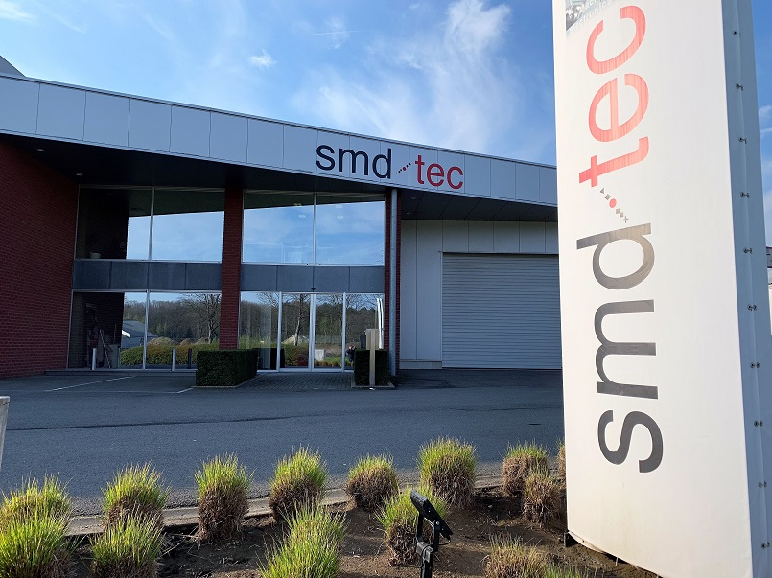
Panasonic Factory Solutions, a division of Panasonic Industry Europe, and SMD-Tec, a leading technical distributor for high-tech capital goods for the production of electronic products in BeNeLux with more than ten years of experience in the markets, announce their future collaboration.
SMD-Tec will distribute the Panasonic Factory Solutions portfolio, particularly Smart Factory software solutions as well as high-end automation products such as Pick & Place machines, printers for various industrial sectors. With extensive sales and service experience, SMD-Tec is a valued partner who extends Panasonic Industry smart factory solutions directly to customers in the Netherlands, Belgium, and Luxemburg.

“Since we collaborate with leading companies from the electronics industry worldwide, we have extensive experience in segments such as SMT production and process optimization. This is also reflected in the reliability of our machines. We consciously combine the advantages of Japanese culture with the benefits of local networks in Europe. This mix of experience and values is something we also want to put at the disposal of medium-sized companies to help them be more efficient and profitable.
As of today, we have predominantly supplied high volumes to internationally positioned tier-one electronics manufacturers in the automotive sector. Particularly across Europe, we would now like to focus on the market segment that comprises medium-sized companies.

One of the challenges is that in Europe, Panasonic is not yet perceived as a solution provider in this segment. The systems we offer are sometimes classified as over-engineered. But that's not true - for example, with our NPM-W2, we provide a flexible SMT solution at an affordable price. That said, the price tag of a machine should not be the deciding factor for investment in electronics production. Instead, parameters such as setup times and unit costs should be the focus. Another challenge is increasing our reach to customers. For this, we are continuously building our network of local partners that contribute to our success with their expertise and long-term relationships in the SMT industry. SMD-Tec is one such valued partner who extends Panasonic Factory Solutions directly to customers in the Netherlands, Belgium, and Luxemburg." says Nils Heininger, Division Director of Panasonic Factory Solutions.

“With SMD-Tec, we found a good partner whose product portfolio fits to our products and who has a good expertise in the world of electronic production. SMD-Tec brings a lot of experience and know-how for a successful cooperation," states Thorsten Jokel, Senior Account Manager, Panasonic Industry Europe GmbH.

Tom van Tongelen, CEO of SMD-Tec, looks forward to the cooperation: "We see a tendency in our region towards high-speed machine requirements, not only for the high volume manufacturer but also for the medium volume producers that require fast turn round of their products and time to market. The high quality and reliability, in combination with the accuracy and speed of the machines, allow the competitive edge that is required by many of our customers in the Benelux region. The product range from Panasonic fits the need for state-of-the-art machine efficiency and automation."

More information on Panasonic Factory Solutions can be found here, and more details of SMD-Tec are accessible here.

###

About Panasonic
Panasonic Corporation is a world leader in the development of various electronic technologies and solutions for customers in the consumer electronics, home, automotive and B2B businesses. The company, which celebrated its 100th anniversary in 2018, has expanded globally and now operates 522 subsidiaries and 69 associated companies worldwide, recording consolidated net sales of 54.02 billion Euro for the year ended March 31, 2021. Committed to seeking new value through innovation across divisions, the company uses its technologies to create a better life and a better world for its customers. For more information on Panasonic: http://www.panasonic.com/global.

About Panasonic Industry Europe
Panasonic Industry Europe GmbH is part of the global group Panasonic and offers automotive and industrial products and services in Europe. As a partner in the industrial sector, Panasonic researches, develops, manufactures and supplies technologies that support the ideology "A better life, a better world".
The company's portfolio covers key electronic components, devices and modules to complete production solutions and equipment for manufacturing lines in a wide range of industries. Panasonic Industry Europe is part of the global company Panasonic Industrial Solutions. More about Panasonic Industry Europe: http://industry.panasonic.eu

About SMD-Tec
SMD-Tec is the most flexible electronics production equipment distributor in the Benelux; founded in 2009 but with hands-on experience in electronics manufacturing since 1994. With a dedicated team of technicians SMD-Tec provides advice and support to ensure its customers can count on efficiently running machines for profitable electronics manufacturing in the Benelux. SMD-Tec is proud distributor of world renowned brands in the industry offering dispensing & jetting, screenprinting, SPI, Pick & Place, soldering, coating, x-ray, testing, marking and handling. More info on: https://www.smd-tec.be/

